ASAN MEMORIAL COLLEGE OF ARTS AND SCIENCE
Velachery – Tambaram Road, Chennai 600 100.

INTERNAL QUALITY ASSURANCE CELL
STUDENT FEEDBACK REPORT
ACADEMIC YEAR 2023 – 24

The College's Internal Quality Assurance Cell (IQAC) requested written feedback from students regarding the teaching and learning processes. Appropriate actions have been taken based on this review, which gathered input from teachers, parents, and students alike. The primary aim of this review is to establish an exceptional feedback system with outstanding quality and services that set it apart from other systems.

Student feedback is collected at the conclusion of each semester through a questionnaire designed to assess the quality of coursework and performance relevant to their field and the overall functioning of the college. Additionally, feedback from alumni who were once regular students is also obtained.

The IQAC constructs a feedback analysis and attribute report, which is then submitted to the Principal. Improvements are implemented based on this feedback to enhance the educational experience for future improvements.

For the academic year 2023-24, the total student population, including both Shift-I (1602) and Shift-II (480), amounted to 2082 students. The survey was conducted among 50% of the students in both shifts, with 800 students participating, including 100 from the postgraduate courses and 700 from the 11 major departments. Similarly, 240 students from four departments in Shift-II participated in this survey.

Table 1
Total Number of Samples
(Department Wise)

SHIFT - I

UG
Department | No. of students
B.Com (Gen) | 104
B.Com (C.S) | 102
B.Com (CA) | 103
BBA | 102
Computer Science | 75
Biochemistry | 42
Microbiology | 46
Psychology | 7
Visual Communication | 55
English | 38
Hotel Manangement | 26
Total | 700

PG

Department | No. of students
MBA | 55
MCA | 24
M.Sc. Biochemistry | 6
M.sc. Microbiology | 15
Total | 100

SHIFT - II

UG

Department | No. of students
B.Com (Gen) | 73
B.Com (AF) | 42
BBA | 50
BCA | 75
Total | 240

The criteria for evaluating staff members in the survey questionnaire included

1. Syllabus Coverage
2. Approachability in Problem Solving
3. Communication Skills
4. Punctuality and Regularity
5. Teaching Methodology

Table 2
Percentage Analysis of the Criteria

 | Excellent | Very Good | Good | Fair | Improvement Required | Total %
Criteria 1 | 69% | 18% | 7% | 3% | 3% | 100%
Criteria 2 | 55% | 16% | 12% | 8% | 9% | 100%
Criteria 3 | 61% | 21% | 10% | 3% | 5% | 100%
Criteria 4 | 85% | 7% | 5% | 2% | 1% | 100%
Criteria 5 | 57% | 20% | 11% | 8% | 4% | 100%

From the above Analysis it is found that,

- Criteria 1, Syllabus Coverage, 69% of students remarked ‘Excellent’, While 18% of the total responses indicated ‘Very Good’, 7% and 3% of the responses pointed out ‘Good’ and ‘Fair’ respectively. 3% of the responses remarked ‘Improvement Required’.

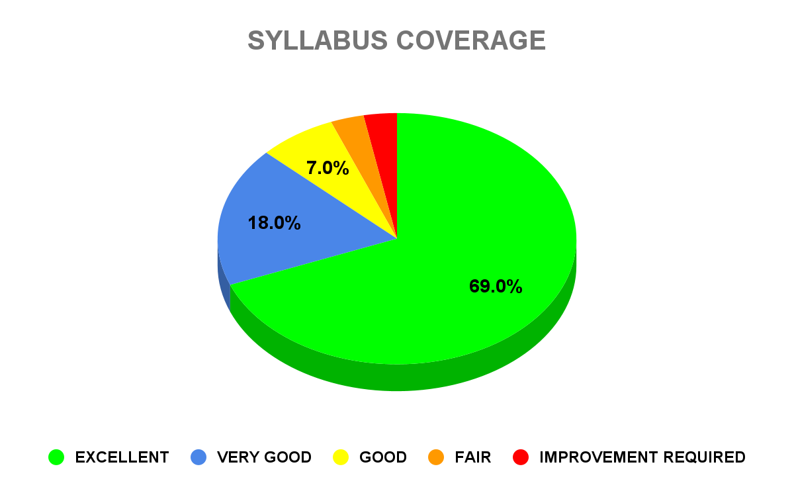

- Criteria 2, Approachability in Problem Solving, 55% of students remarked ‘Excellent’, While 16% of the total responses indicated ‘Very Good’, 12% and 8% of the responses pointed out ‘Good’ and ‘Fair’ respectively. 9% of the responses remarked ‘Improvement Required’.
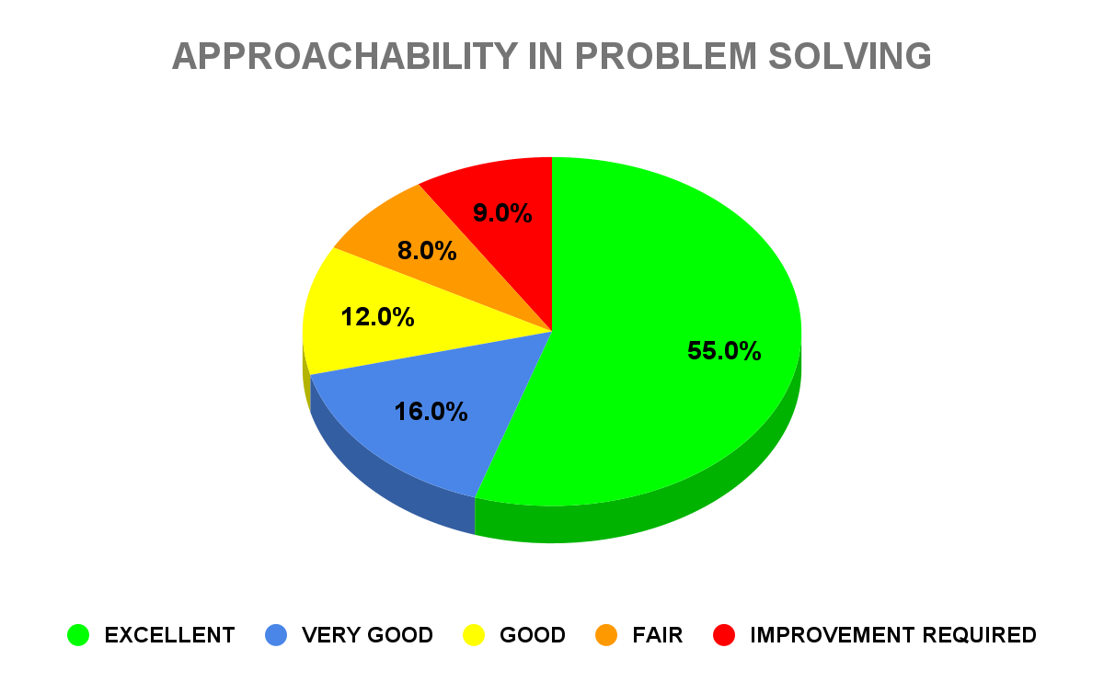

- Criteria 3, Communication Skills, 61% of students remarked ‘Excellent’, While 21% of the total responses indicated ‘Very Good’, 10% and 3% of the responses pointed out ‘Good’ and ‘Fair’ respectively. 5% of the responses remarked ‘Improvement Required’.

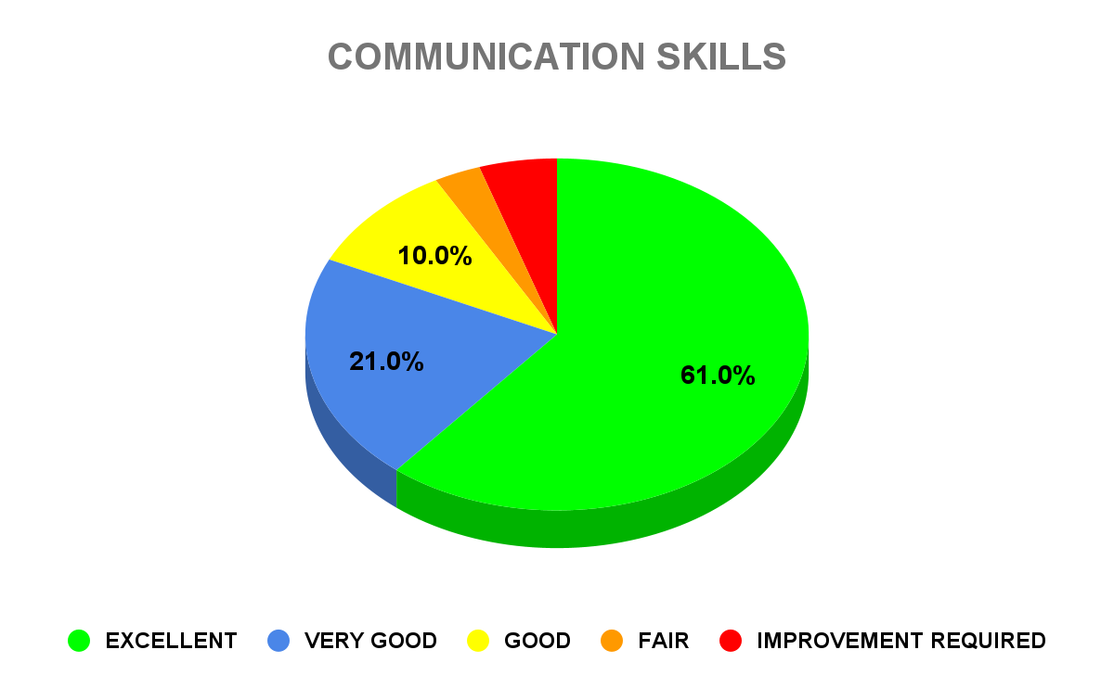

- Criteria 4, Punctuality and Regularity, 85% of students remarked ‘Excellent’, While 7% of the total responses indicated ‘Very Good’, 5% and 2% of the responses pointed out ‘Good’ and ‘Fair’ respectively. 1% of the responses remarked ‘Improvement Required’.

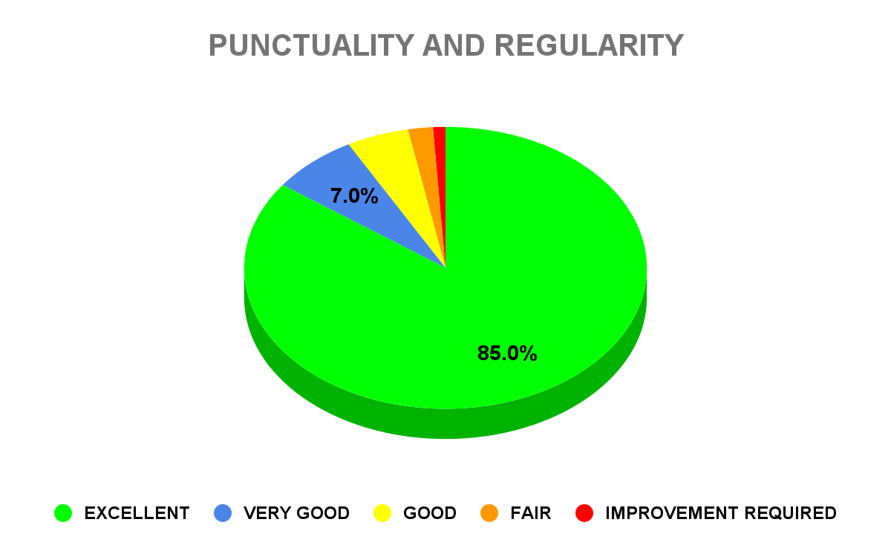

- Criteria 5, Teaching Methodology, 57% of students remarked ‘Excellent’, While 20% of the total responses indicated ‘Very Good’, 11% and 8% of the responses pointed out ‘Good’ and ‘Fair’ respectively. 4% of the responses remarked ‘Improvement Required’.

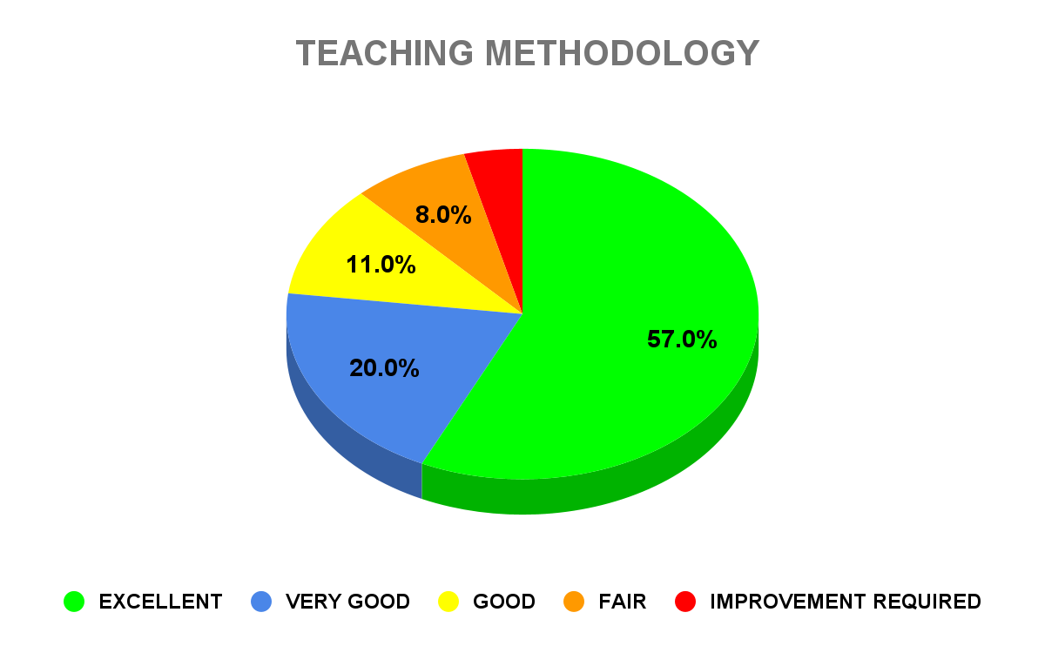
Consequently, we draw our conclusions based on the feedback received from the highly regarded candidates of the academic year (2023-24). In light of the valuable suggestions presented by students, the grievance redressal cell and IQAC, under the Principal's guidance, have committed to implementing remedial measures and corrective actions in response to the students' recommendations.

