ASAN MEMORIAL COLLEGE OF ARTS AND SCIENCE
Velachery – Tambaram Road, Chennai 600 100. INTERNAL QUALITY ASSURANCE CELL STUDENT SATISFACTION SURVEY ACADEMIC YEAR 2023– 2024

SYLLABUS COMPLETION ON TIME.
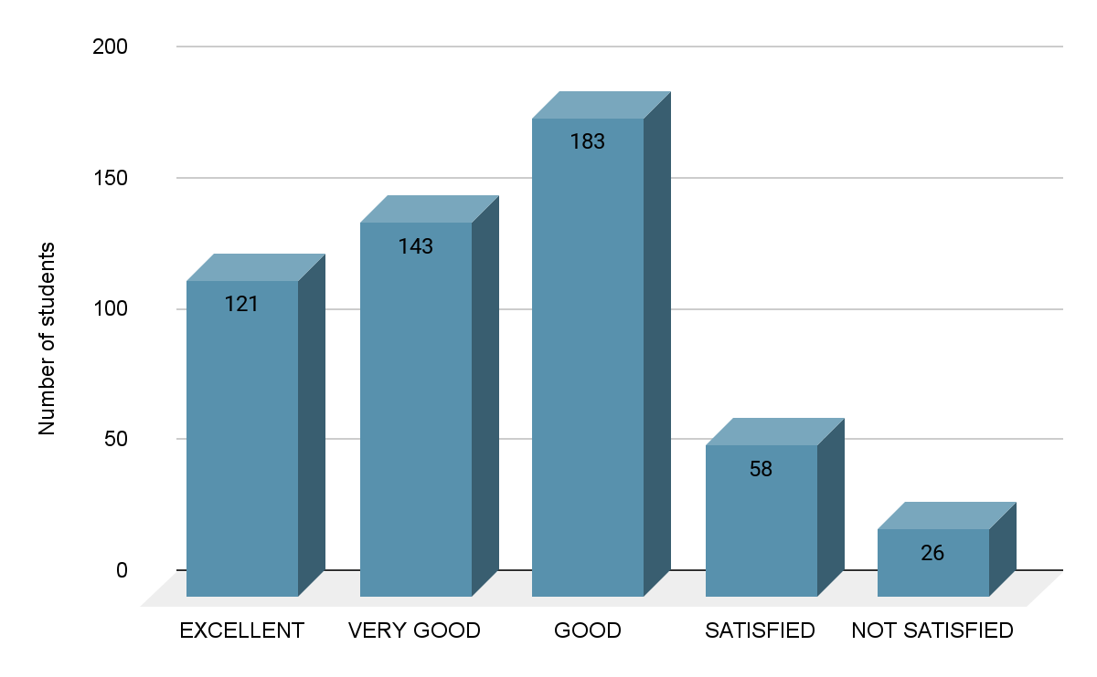

2. TEACHER'S CLASS PREPARATION LEVEL

AND COMMUNICATION
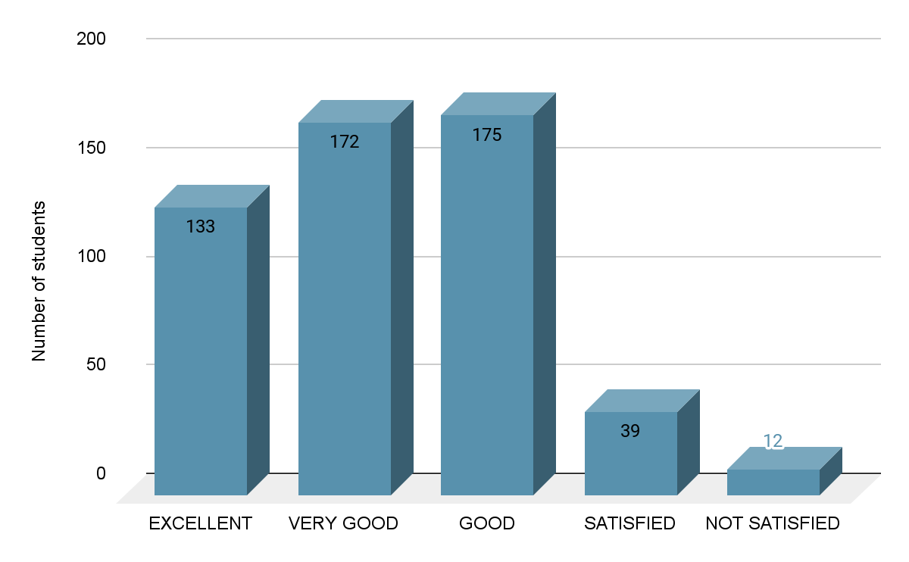

3. TEACHER'S ICT TOOL USAGE

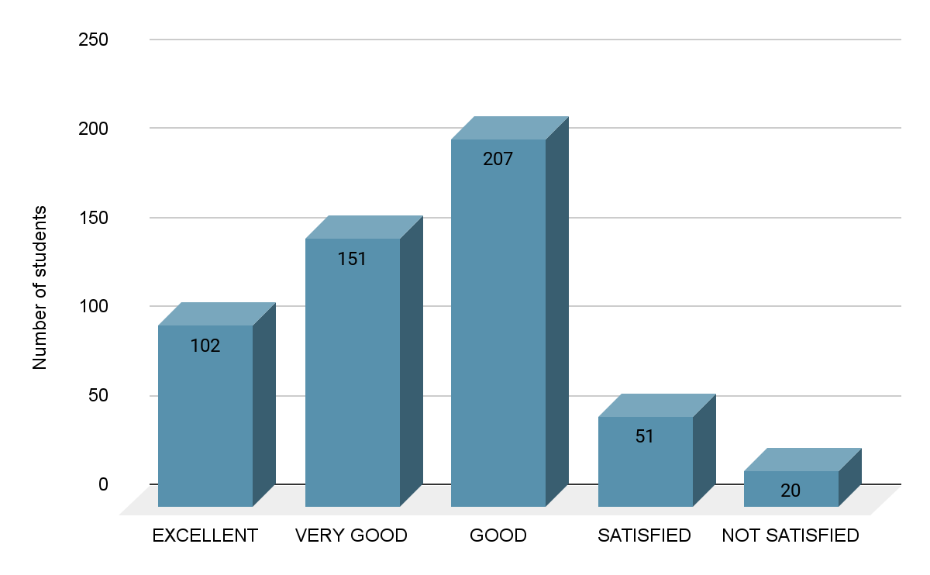

4. TEACHER'S INTERNAL EVALUATION

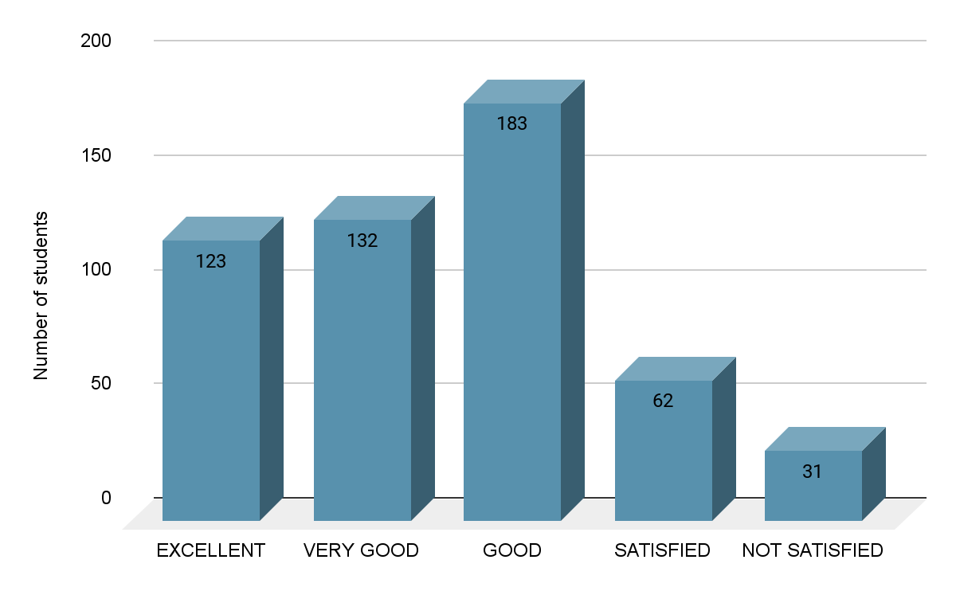

5. ENCOURAGEMENT TOWARDS SPORTS, CULTURAL AND EXTRA-CURRICULAR ACTIVITIES

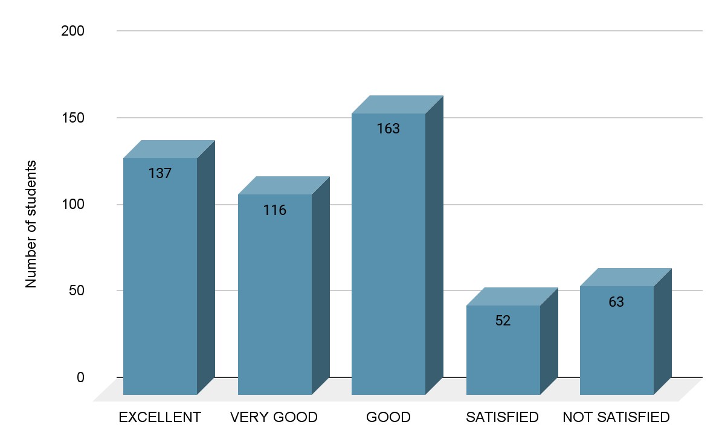

6. ENCOURAGEMENT TOWARDS NSS, ROTARACT AND OTHER EXTENSION ACTIVITIES

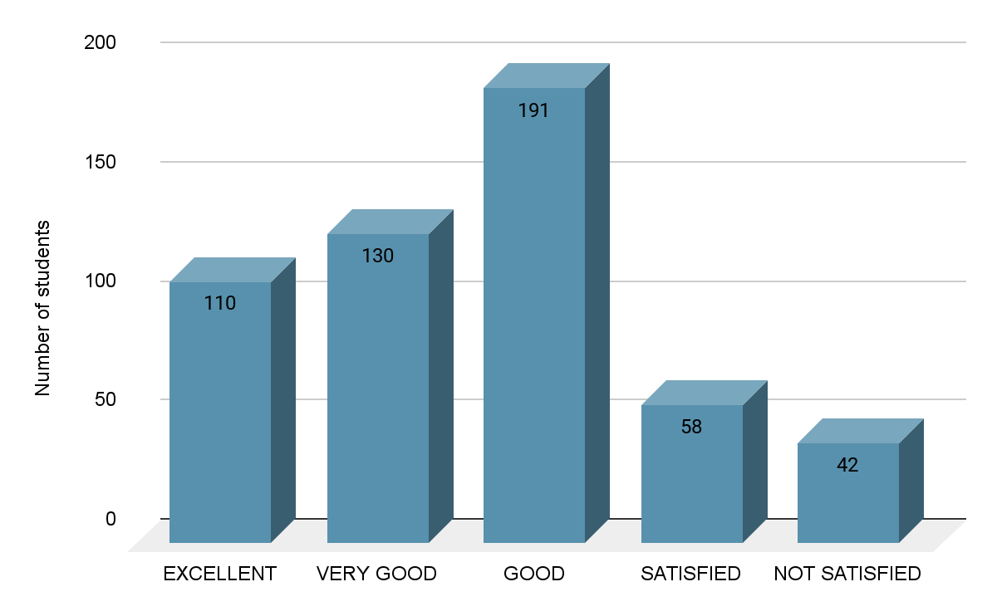

7. INFRASTRUCTURE FACILITIES

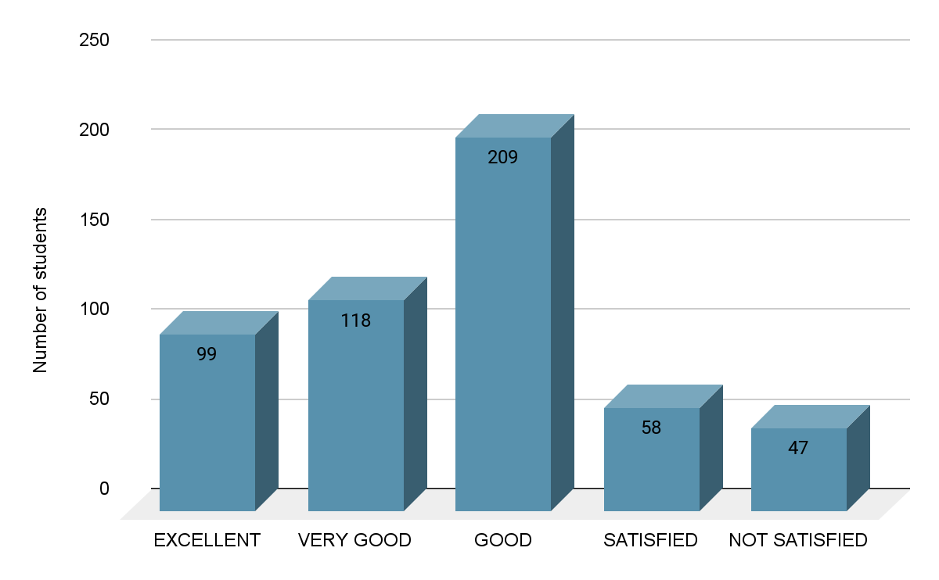

8. EFFECTIVENESS OF TRAINING ON

EMPLOYABILITY SKILLS

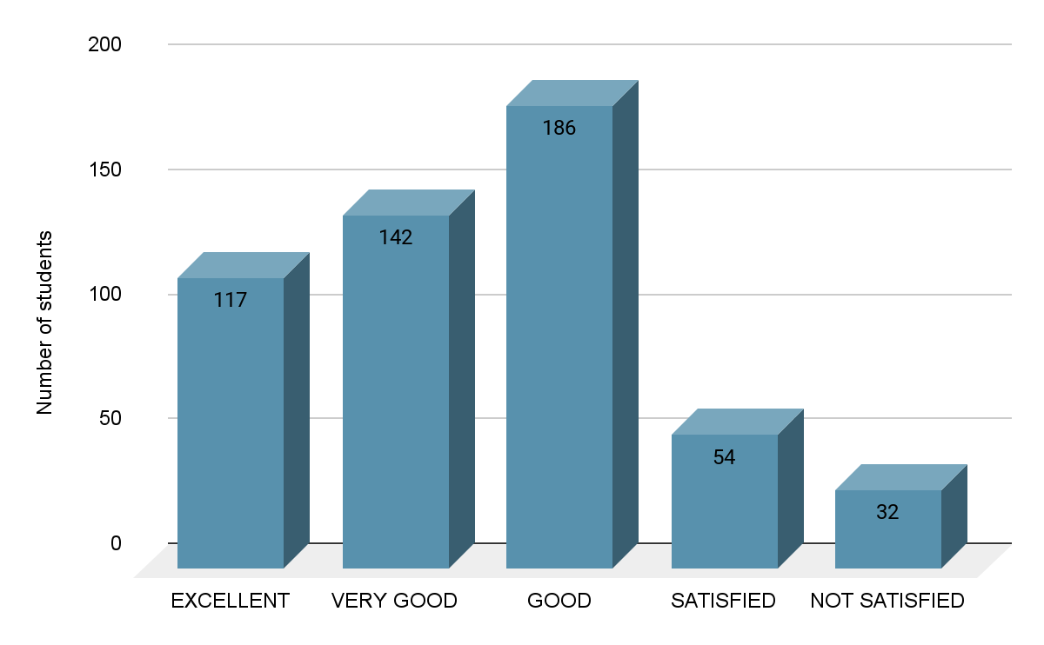

9. EFFECTIVENESS OF VALUE ADDED AND ADD-ON PROGRAMS

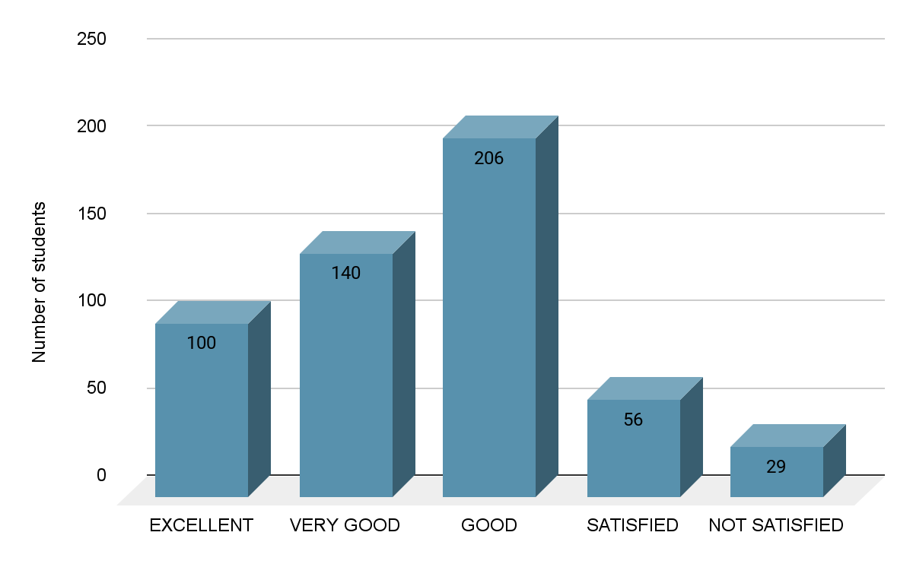

10. INTERNSHIPS AND INDUSTRIAL VISITS

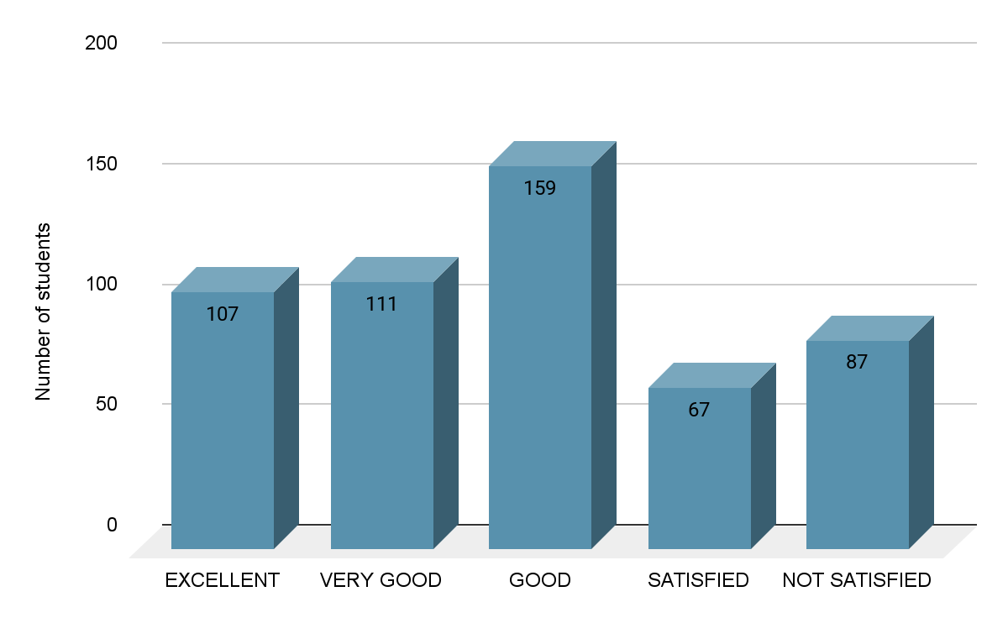

11. PLACEMENT OPPORTUNITIES
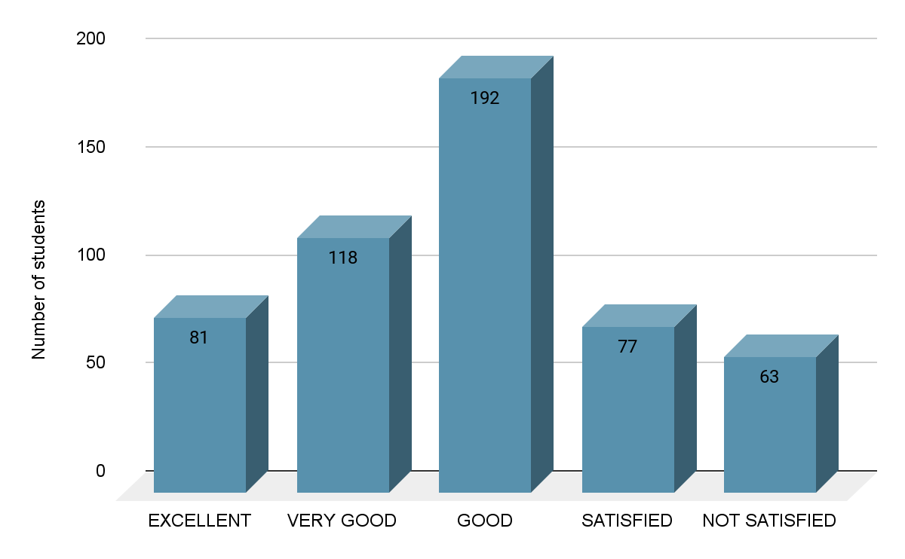

11. GRIEVANCES REDRESSALS
