BBA – ALUMNI TESTIMONIALS
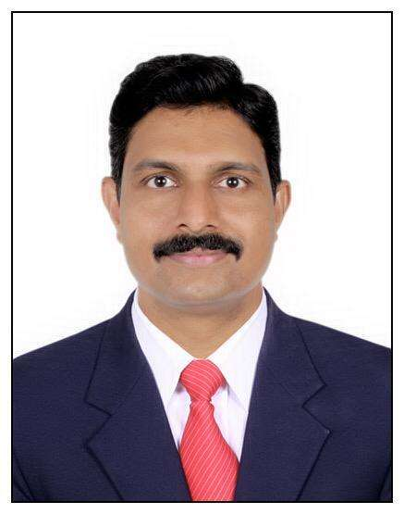
Mr. Kiran Kumar M
BBA - 2004-2007 Batch
Founder & CEO
KUBIX-IT Solutions & Services, Bengaluru.
My Graduation with ASAN College and especially with my department of BBA, was so excellent since it gave a lot of good experience in terms of Personal & Academics. The best part was the support & guidance of our HOD-Ms. Vanaja Madam, who she is an iron lady and a best teacher, who inspires and support a lot in our academics. Even with academics we had a lot of fun too, very unforgettable memories in my life.
**********************************************************************************
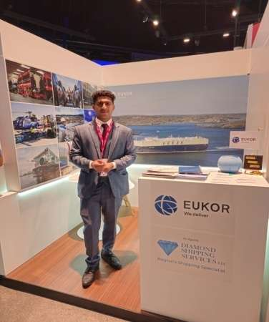
Mr. Abijith
Batch 2015-2018
Operation Executive , Sharaf Group, Dubai.
Recognizing the academic knowledge gained, along with practical skills and life lessons acquired

**********************************************************************************
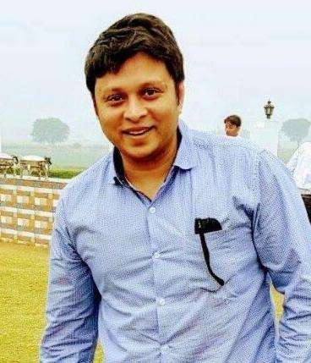
Mr. Cholapurath Rohith
Planter /Business, Kozhikode, Kerala.
Batch 2000-2003
Life in Asan was a turning point of my life where I complete BBA and pursued MBA from Singapore and had an opportunity to work in a shipping company there.
Life in Asan was filled with good memories and beautiful people around,few I am still in touch with. Thank you to our HOD Vanaja ma’am, Principal Ms Indulekha and all my teachers.
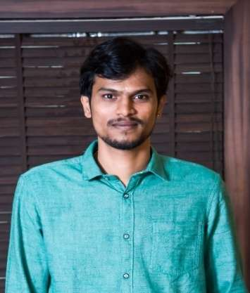
Mr. Sreejith K R
Batch 2008 – 2011
Lead – Amazon, Chennai.
Asan college did not just educate us, I still remember the care and that the professors gave to each and every students was amazing, personality development program which was organized by our department literally changed my life, I never thought I would get a job through campus interview, however at the end I walked out with 3 offers HCL, DELL and ADIENT. Am really thankful to the entire BBA department and Asan especially Vanaja mam for all the support.

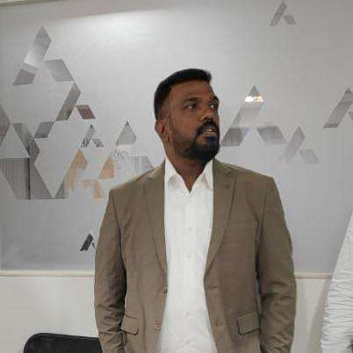
Mr.Ganesh Krishnamurthy
Batch 1998 - 2001
Company - Muthoot Fincorp Ltd.
Grade - Deputy Vice President
Designation - National Collections Head.
Location - Chennai
I did my schooling in a boarding school at Kodaikanal. Post that I joined Asan college. The place which taught me so many things. First of all I was happy as I was out from hostel and Asan made my life double happy, a great place to study. Had lots of friends and faculty were too good under the lights of Vanaja Madam , Arya Mala madam , ethiraj sir , Rajendran sir, sundaravadivel sir and Venkatesan sir and many more.
Mr. Vignesh Pannerselvam
2011 to 2014
BBA
Cha Food And Beverage Pvt Ltd , Chennai
Sales Director
I am thankful to all the faculty members of the College for their continuous efforts and support. Apart from excellent academic experience, I also gained the benefits of being a part of Cultural Student' body. I cherish every moment spent at Asan Memorial College of Arts & Science
Mr. VENUGOPAL. S
BATCH: 2010 -2013
Director , BILLINGEDGE RCM PRIVATE LIMITED, Chennai
I began my journey as a BBA student. My three years at ASAN were crucial in shaping my career. My BBA Department staffs assisted me in discovering my personal strengths and shortcomings.
I learned self-motivation and discipline, as well as study strategies that I may apply for the rest of my life. As a proud Asanite, I sincerely hope that my juniors would take ASAN to new heights and develop into the finest versions of themselves.

Mr. Khirod Chandra Mahapatra
Batch 2001-2004
Deputy General Manager - Human Resource
Landmark Group, Mumbai
College is a place which brings up the hidden talents behind you and shapes you up as a skilled person. Proud that my college is one among them. It gave me an excellent platform where I could think beyond the box and showcase my innovations thereby achieving beyond limits. I am very much thankful the BBA department for the immense support received from faculty and my seniors as they played an integral part through my journey
**********************************************************************************
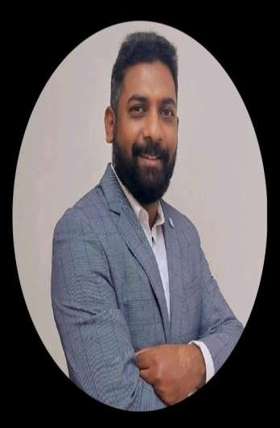
Mr. Nixon James
Batch 2002 to 2005
Senior Sales Engineer
Faisal Jassim Trading Co.(L.L.C) , Dubai
I spent the best days of my life at Asan College of Arts & Science & Business Administration department . The Teaching Staff & especially HOD Madam were very supportive and their guidance helped me to reach what i am today.

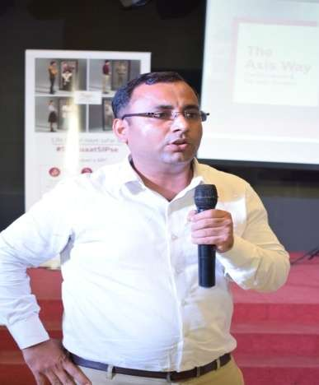
Mr. Sazib Saha
Batch-2002-2005
Zonal Manager
East 1- AXIS Mutual Fund Kolkata, West Bengal
Proud to be an alumni of BBA department of Asan Memorial College of Arts & Science which had built the foundation for my management skills through which now I am managing a Big Team of 55 Members.

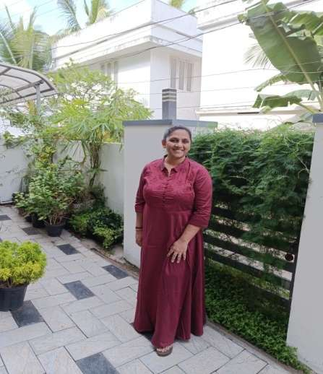
Ms.Seema Syed
Batch 1998-2001
Proprietor - Sunshine Education, Trivandram
Proud Asanite. BBA department has given me all that education and management skills because of which I am and who I am now . Thank you all, from the bottom of my heart thanking the entire faculty who have been there for their students all the time. Thank you Vanaja mam you have been the best all through.
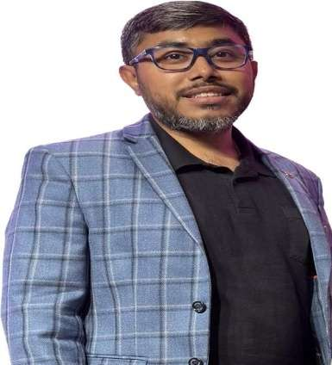
Mr. Alok Kumar Upadhyay
Batch 2008-2011
Head of Operations
Aditya Birla Capital, Mumbai
Navigating the BBA journey at Asan Memorial College was a blend of insightful learning and character-building experiences. Vanaja Ma'am's guidance not only imparted business knowledge but also sparked my curiosity. Yethiraj Sir's real-world stories made classes engaging and relatable. Kavita Ma'am's support fostered a sense of togetherness among students. Even the occasional punishments from teachers, delivered with a positive intent, instilled discipline and taught valuable life lessons. Beyond the subjects, it was this mix of guidance, real-life examples, and camaraderie that made my time at Asan Memorial uniquely enriching”
“Asan? Where learning transcended textbooks, bunking classes created memories, punishments sculpted character, and the BBA teaching staff, along with lifelong friends, turned the ordinary into the extraordinary – making my college journey truly 'Asan'-tastic!”

Mr. Shabeeb Shaheer
Batch 2009 - 2012
Quality Associate
Jaguar Land Rover Ltd, United Kingdom
“My experience at AMCAS has been fantastic. The administration course in itself has helped me hone my leadership skill and self esteem, building my confidence to take the challenges of life.
The faculty were like a family, always encouraging and understanding. I have had some of my best memories participating in various cultural events and sports. AMCAS has given me the foundation to build my career in management”

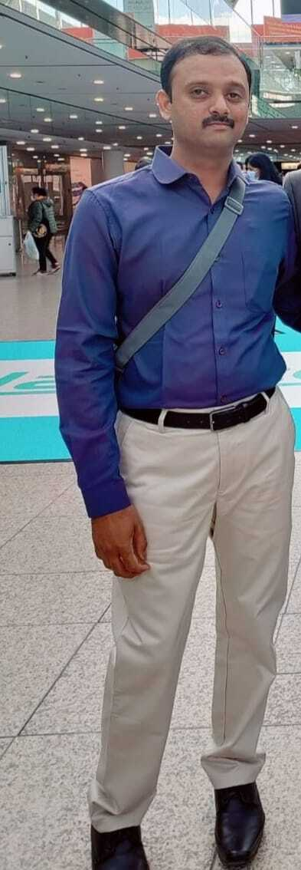

Mr. M. SARANATH
BBA 1998 TO 2001
Founder - S CUBBE SHIPPING AGENCIES, Chennai
Director - MANCHU TOUGHEND GLASS PVT LTD, Chennai
"Wonderful college and our department had lovely pals. We all had moments unforgettable"
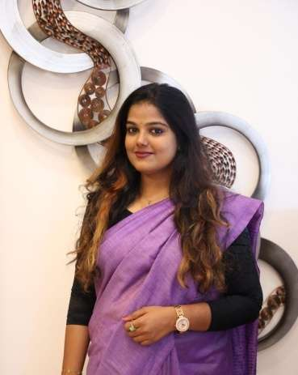
Ms. Anitha Bai R.P
Batch : 2011-2014
Designated Partner
B.R.Shastry Logistics LLP, Chennai
I have spent my golden days at Asan Memorial College of arts and science. I would like to express my gratitude to the faculty for their excellent support.I was given a lot of opportunity to participate in inter-college events and enhance my skills. From seminars to cultural activities , it was truly a memorable journey into adulthood.I made some valuable friends.
My HOD Vanaja ma'am and members of faculty Kavita ma'am, Roseline ma'am and Ethiraj sir were pillars of strength who motivated us and gave me a sense of confidence to face the challenges ahead. I got many job offers through the college placement process but chose to step into business.
Always a proud Asanite ! I will always be grateful for the sound foundation provided by Asan College.
**********************************************************************************
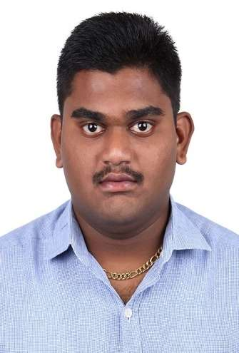
Mr. G.Anand Sekaran
Batch 2014-2017
Proprietor – VITECH, Chennai
It is the best department which shaped my career my life. The staff members were the best when it comes to learning, they helped us a lot in each and every aspect of the course. Asan college an excellent college to study learn and to prospect in our career. In one word my college was the eye opener and the gateway for my career and life.
******************************************************************************
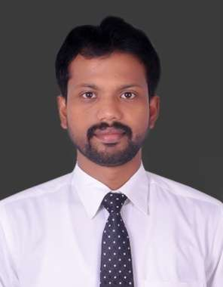

Dr. T. S. Edwin, Ph.D., M.B.A., PGCM (Business Analytics)., DNIIT
Associate Professor | School of Management
Presidency University | Bengaluru
"Reflecting on my BBA college years (2000 – 2003) is like flipping through the pages of a cherished novel, each chapter brimming with growth, challenges, and unforgettable moments. My time at Asan Memorial College was nothing short of transformative.

The campus, with its majestic architecture and vibrant energy, became the backdrop to the most formative years of my life. The faculty members were not just educators; they were mentors who ignited my curiosity and passion for learning. A few notable facultymembers of BBA department are Ms.Vanaja Ma’am, Mr.Yethiraj Sir, Mr.Nagarajan Sir, and Mr.Rajendran Sir… Their guidance transcended textbooks, fostering critical thinking, and shaping my worldview. I actively took part in all the department, college and inter-college activities with the support and guidance of my faculty members.

What truly set my college experience apart was the diverse tapestry of friendships that enriched my journey. The college wasn't just a place of academic pursuit; it was a crucible for self-discovery. The extracurricular activities, clubs, and events allowed me to explore my interests beyond the classroom. These experiences cultivated skills, resilience, and a sense of purpose that extends far beyond the boundaries of the campus.

As I walked across the stage on graduation day, I couldn't help but feel a profound sense of gratitude. My alma mater had not only equipped me with knowledge but had also nurtured my character, instilling values that guide me to this day. The old college stands as a symbol of growth, friendship, and the endless possibilities that unfold when one embraces the journey of education.

In essence, Asan Memorial College was more than an institution; it was a transformative sanctuary that sculpted the foundation of my identity. I am forever indebted to the experiences, relationships, and lessons that have become the cornerstone of who I am today.
**********************************************************************************

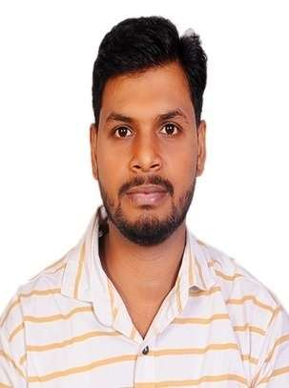

Mr. B Yadava Rao
2010 – 2013 ( BBA)
Designation - ENO III
Credit Suisse ( UBS Group), Pune
My Life at Asan Memorial college of Arts and Science was unforgettable and memorable and when it comes to Department of Bachelor of Business administration (BBA) has been a great contributor to the development of my personality in both ways professionally and personally. The head of department and mentors in the department helped to enhance my academic and interpersonal skills. And I would like thank the faculty who supported and corrected me in many ways.
**********************************************************************************
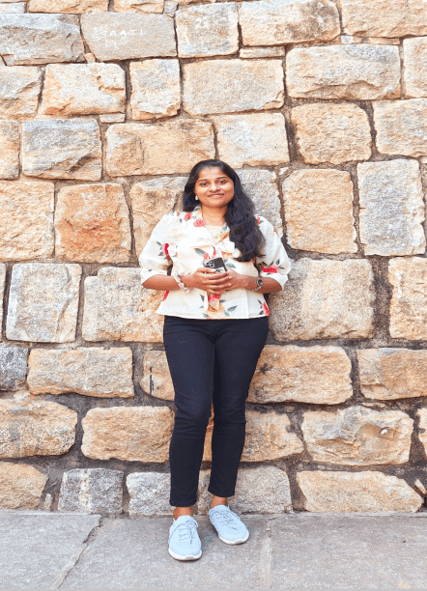
Ms. Ferlin Jenisha
BBA – Batch 2016-2019
Senior Analyst – Barclays, Chennai
My time as a student at ASAN was a highly enriching experience. The skilled faculty members, with their expertise and willingness to assist, played a pivotal role in shaping my academic journey. I was so ecstatic to commence my professional journey in a prestigious organisation, TCS and thereby now in a well established UK bank. I owe this incredible opportunity to the unwavering support of my HOD and the professors of BBA department. The years spent at this institution have transformed my personality, honed my skills, and broadened my perspectives on the world. I feel immensely grateful for being a part of this outstanding academic community that has empowered me to pursue my dreams and achieve success in my career. Specifically, I commend the effort put in by the teachers in giving timely, valuable feedback and suggestions that are exemplary for the all-round self development. In my time here, I have had the privilege of forging fantastic friendships and knowledge that will undoubtedly prove invaluable in my future professional pursuits. The time spent in ASAN will be evergreen.
**********************************************************************************

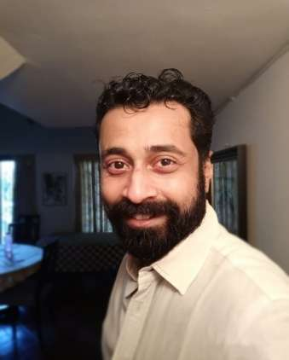

Mr. Hari Shankar Gopakumar
Batch 2006-09
Executive Officer
Confederation of Indian Industry,
Kerala State Office
“During my time at Asan Memorial College of Arts and Science from 2006 to 2009, the Department of Business Administration provided an enriching academic journey. The faculty's dedication to nurturing critical thinking and practical skills prepared me for the dynamic business world. The vibrant campus culture, coupled with cutting-edge curriculum, shaped not just my education but also lifelong connections. Grateful for the transformative experience at Asan Memorial College."
**********************************************************************************
Mr. Jerin S George
2016-2019 batch
Senior Executive
NTC Logistics India Private Limited.
The Bachelor of Business Administration program at Asan College is commendable, offering a well-rounded curriculum that blends theoretical knowledge with practical applications. The dedicated faculty fosters a dynamic learning environment, equipping students with essential skills for the business world. The department's commitment to innovation and industry relevance reflects positively on the overall educational experience.
**********************************************************************************

Mr. Mahesh AV
BBA - Batch :2009-2012
Designation: Business Development Manager
Company: Enkay Express BR of Al Rai Logistica
Dubai , United Arab Emirates
In my entire life where I am proud of myself specially on my decision making is that I opted to choose and decide to enroll myself in Asan memorial college chennai in the department of BBA.
I still remember I was 18 years old when I took the decision to join Asan memorial college and was not sure how I am going to adjust as I was been raised in north india during my childhood but only good thing that I had with me was being born as a tamilian.. so there was no language barrier .
Most of the time we think when we get in a college just focus on your studies, get the relevant degree, attend graduation ceremony and get a good on campus interview and just settle down ..
But this institution has a overall different curriculum where students are identified the key potential personalities traits and give a new kick start..
For me specifically my personality got changed because of the trust and confidence that my department faculty had on me , specifically Ms Vanaja ( HOD) , she could easily see in me the future brightness , and I always took the opportunity whenever she gave and I made sure I justified to the fullest ..
I left from my institution as best outgoing student in my department, that would have nothing been possible without my department support and college other staff.
Till today my teachers remember me and bless me , and I am happy that more students like me will get moulded and see huge differences in their personality when they come out from there.
I share credit of my successful life to the college department faculty members
Ms Vanaja
Ms Kavitha
Mr Yethiraj
Thanks for always supporting me and having a faith in me ..
You will be always remember and till my next generation.
I whole heartedly pray for wellbeing in their personal life , heath and prosperity for my teachers and college and other department staffs .
**********************************************************************************
Ms. Divya Shree
BBA - Batch 2010-2013
Entrepreneur, Chennai
Asan and I have a merry connection for my whole-life , it always felt like home for me.BBA life was a wholesome of memories down the lane. Touchwood to those memorable days❤
**********************************************************************************
Mr. Ananthakrishnan Baburaj
BBA – Batch 2020 -2023
Entrepreneur
PB Food Products, Bread Toast Bistro
The BBA department stands out as a vibrant cornerstone at Asan Memorial College of Arts and Science. This department is dedicated to ensuring that every graduating student not only receives a degree certificate but also departs with indelible memories of diverse extracurricular activities, strong faculty connections, and on top imbued with the moral knowledge for career success.
**********************************************************************************

