**Mr. Dakshinamurthy**

**Batch 2004-2007**

**Oracle Private Ltd**

Dakshinamurthy is highly experienced IT professional with an extensive background in enterprise solutions, data architecture, and cloud technologies. His career spans over 17 years, where he has held leadership roles in prominent companies across diverse industries, such as telecom, banking, and finance. Dakshinamurthy holds a Master of Business Administration (MBA) in Systems from Madras University, Chennai. His reflection on his educational journey highlights the significant role that Asan Memorial College of Arts & Science played in shaping his career. By completing his Bachelor of Science in Computer Science with first-class honour’s, he not only acquired a solid foundation in technical knowledge but also gained practical skills that set him up for success in the IT industry. The educational experience at Asan Memorial College was a catalyst in his career, and it gave him the necessary skills and confidence to secure positions in leading technology companies such as IGATE, Infosys Technologies Ltd, and Cognizant during their off-campus placement.

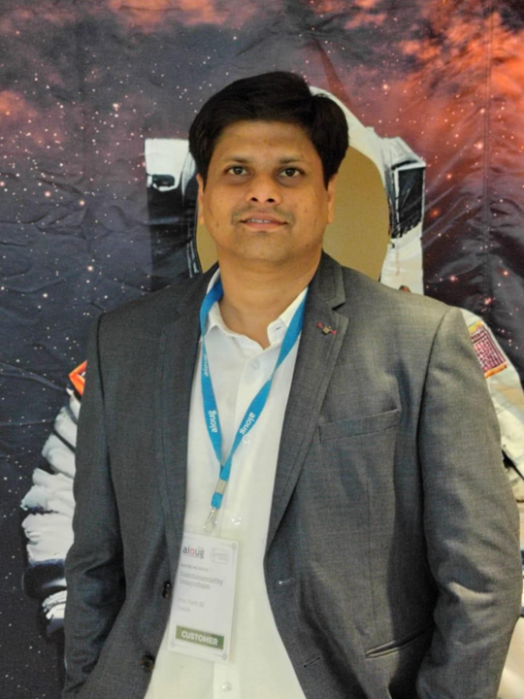

**Mr.Vishal Krishna**

**Batch 2012-2015**

**Principal Cloud Architect**

My education at Asan Memorial Institution was the cornerstone of my professional journey. The institution's rigorous academic curriculum and exposure to cutting-edge technologies gave me a strong foundation in software engineering and problem-solving. The support and mentorship from the faculty helped me build expertise in areas like programming, automation, and data management. These skills have been vital in my role at Sutherland Global Services, enabling me to excel in Robotics Process Automation and deliver impactful solutions. I am deeply grateful to Asan Memorial Institution for shaping my career.

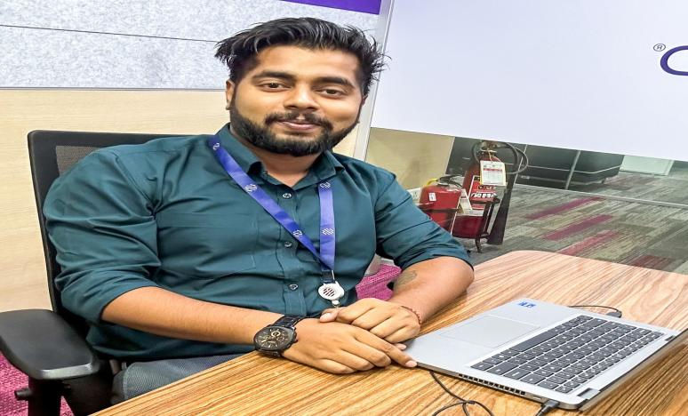

**Ms. Rajalakshmi**

**Batch 2019-2022**

**Five9s Solution Ltd**

The college fostered a learning environment that balanced academics with practical exposure. Through projects and seminars, I gained hands-on experience in applying theoretical knowledge to solve real-world problems. Additionally, the college encouraged participation in sports, public speaking, cultural events, and career guidance programs, which helped me build confidence and discover my potential beyond academics. "Asan Memorial Institution shaped my career by providing not just education but also the confidence, skills, and opportunities to excel in life. The dedication of the staff and their practical teaching methods, along with project and seminar-based learning, were instrumental in my success."

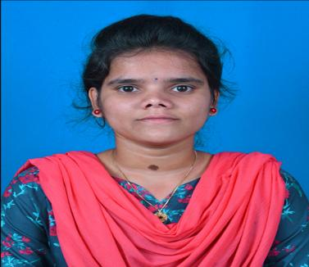

**Mr. Rajagananapathy**

**Playback Singer**

I am truly grateful for my time at Asan Memorial Arts and Science College, Batch 2016-2019. The unwavering support I received during my BSc Computer Science course, while pursuing my passion for singing, made my journey exceptionally enriching. The college not only provided a robust academic environment but also accommodated my frequent travels for musical commitments, allowing me to strike a harmonious balance between studies and my profession. The encouragement and understanding from the faculty and administration made Asan Memorial a nurturing space for both my educational and artistic endeavors.

